**Problem Statement:**

Write a Pig UDF to find the tweets posted by @realDonaldTrump from the given dataset.

**UDF:**

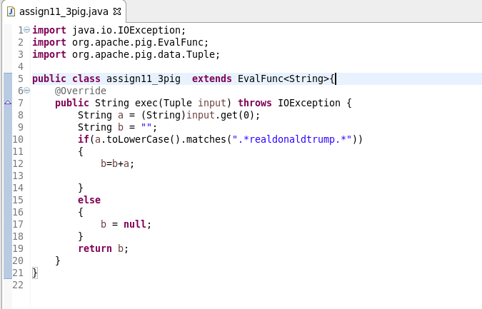

**Pig script:**

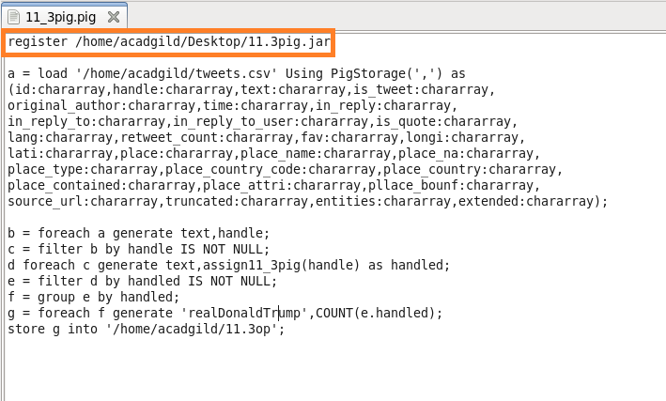

**Running pig script:**

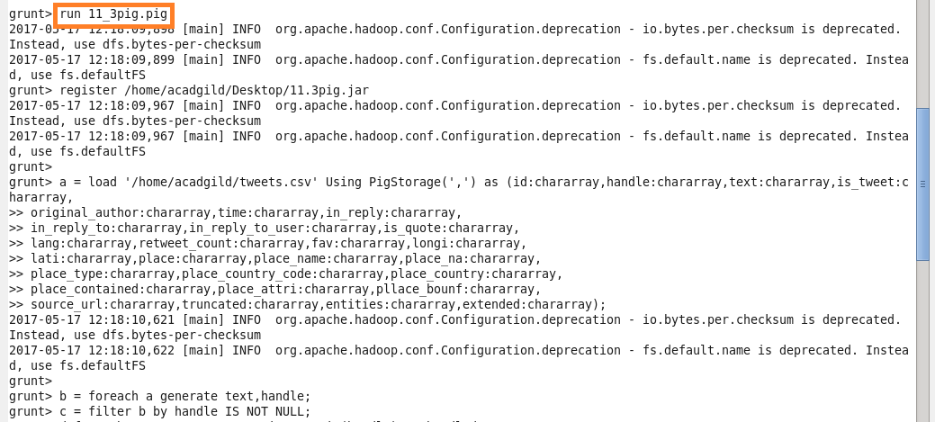

**Output:**

